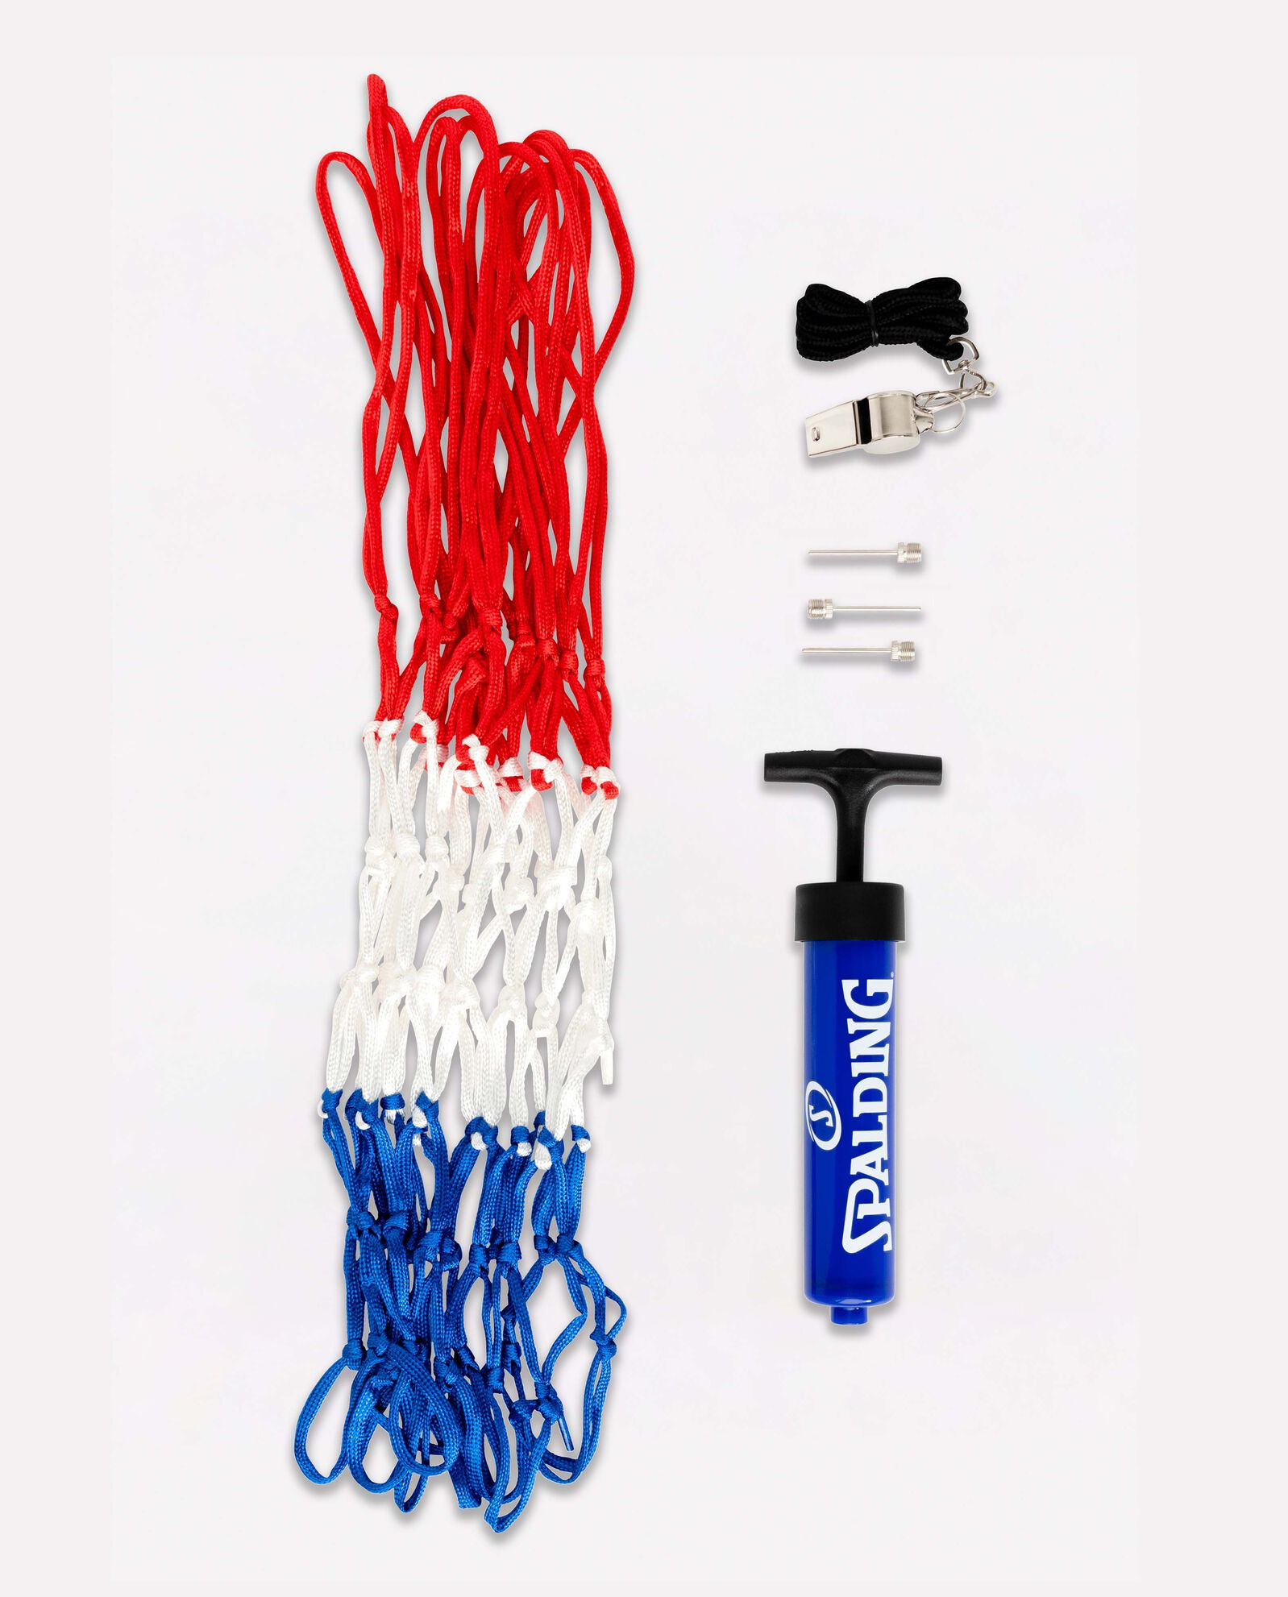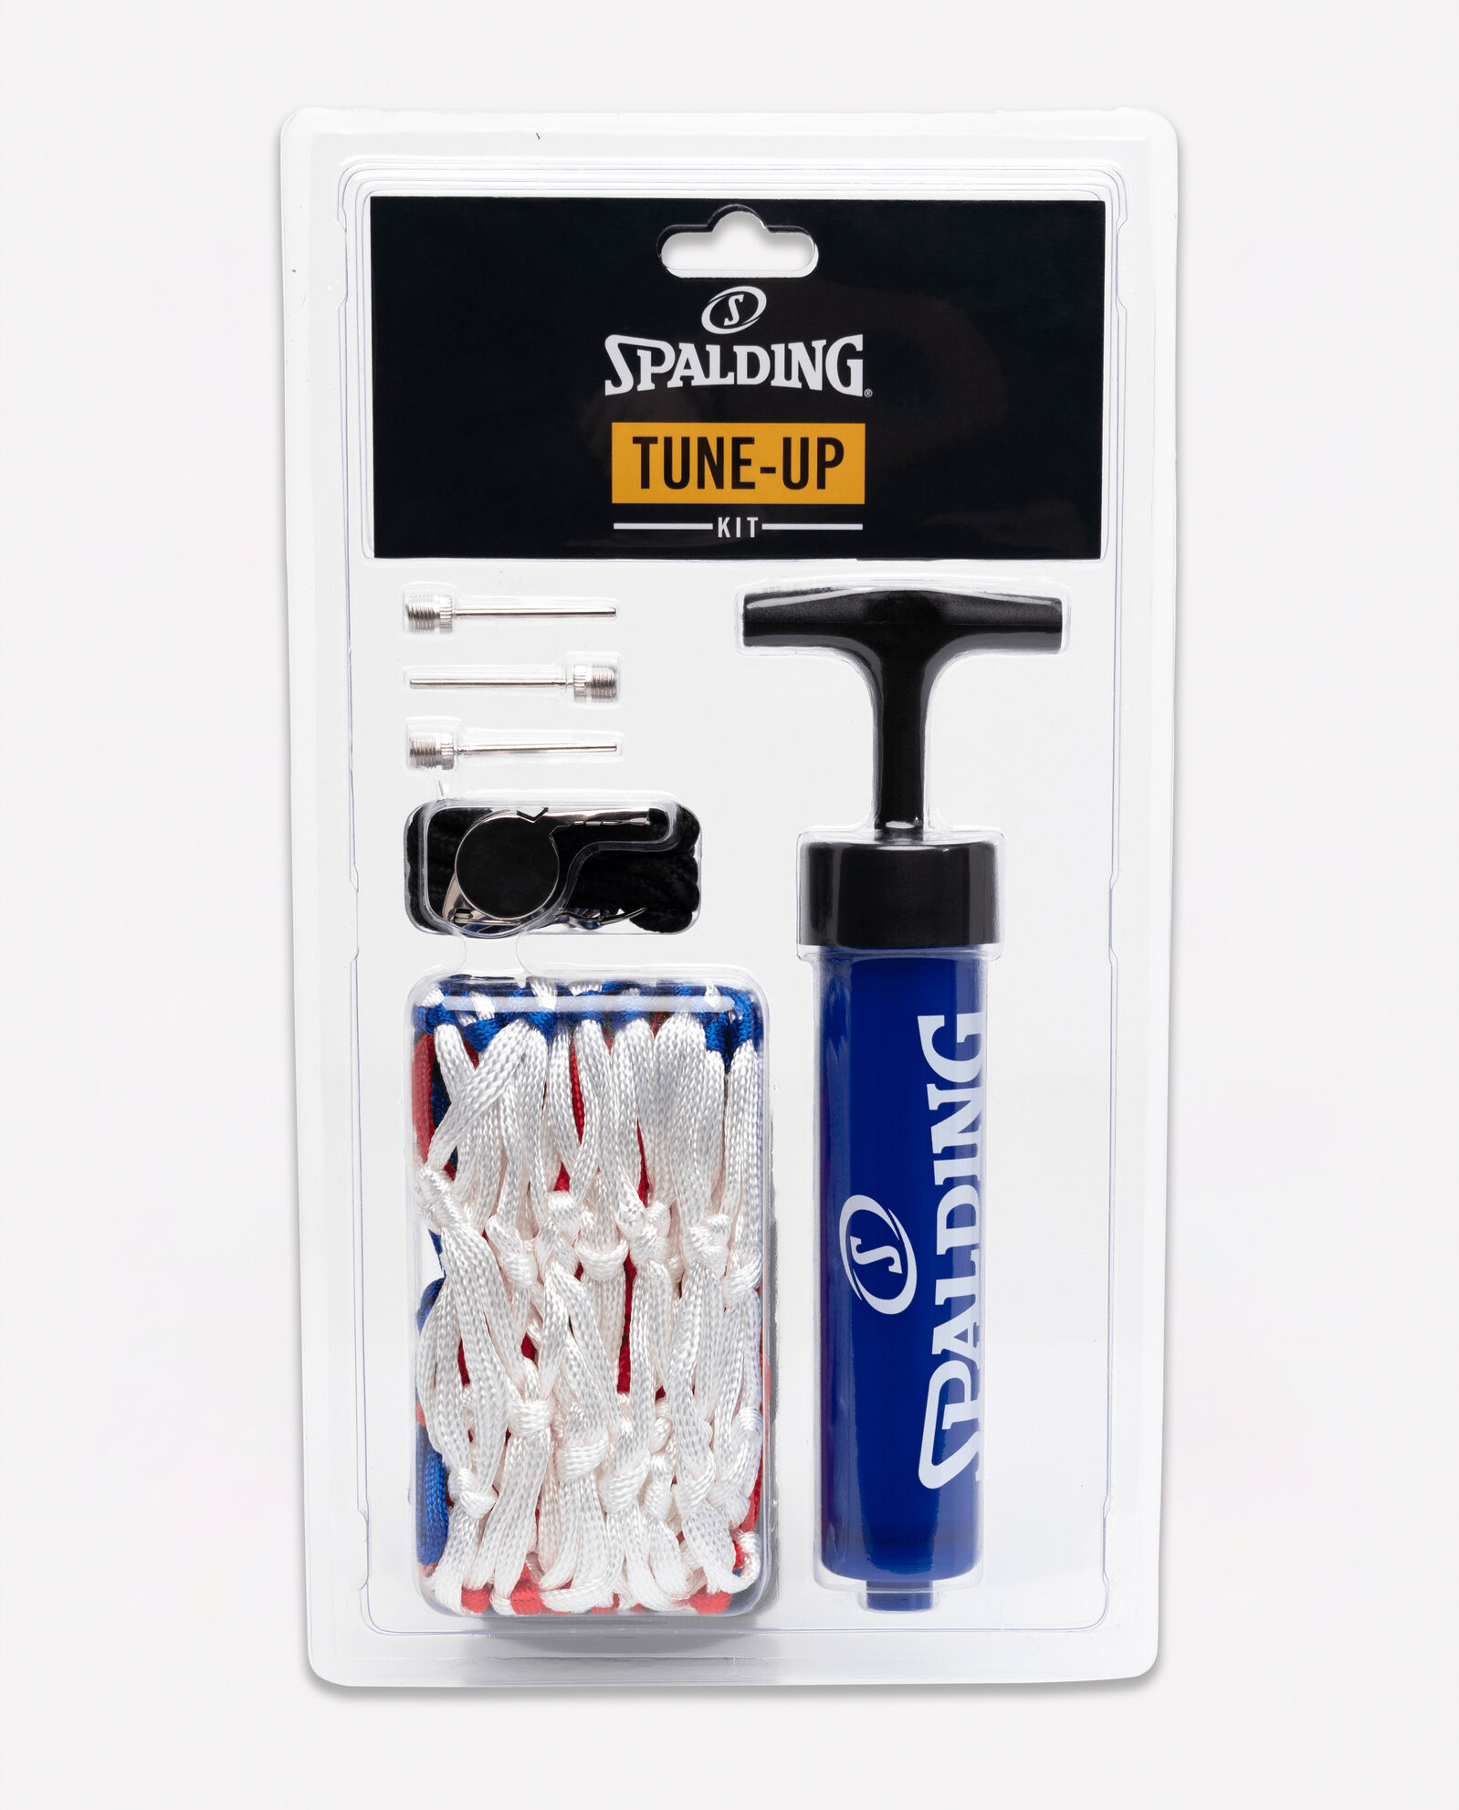

SPALDING BASKETBALL TUNE-UP KIT

Stay one step ahead of the game. The Spalding Basketball tune-up kit includes a single action pump that can be used on any air-filled sports ball. It also equips you with three inflation needles, a whistle and an all-weather basketball net.

**DETAILS:**

* Includes single action pump with three inflating needles, metal whistle and all-weather net
* Backed by Spalding's Warranty
* Item Number: 8300SP